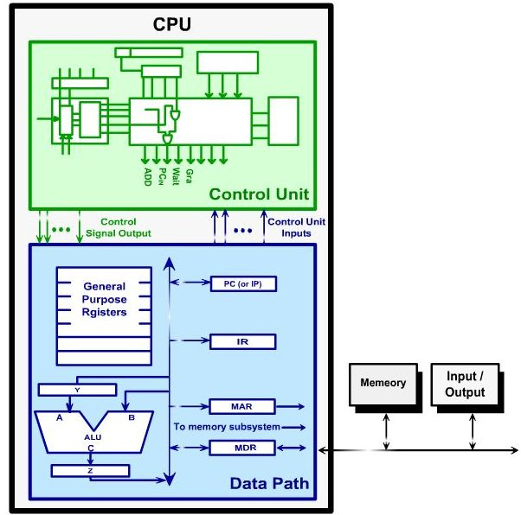

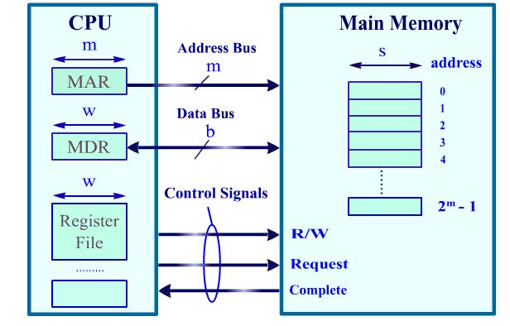
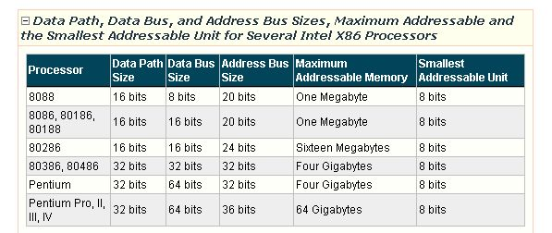

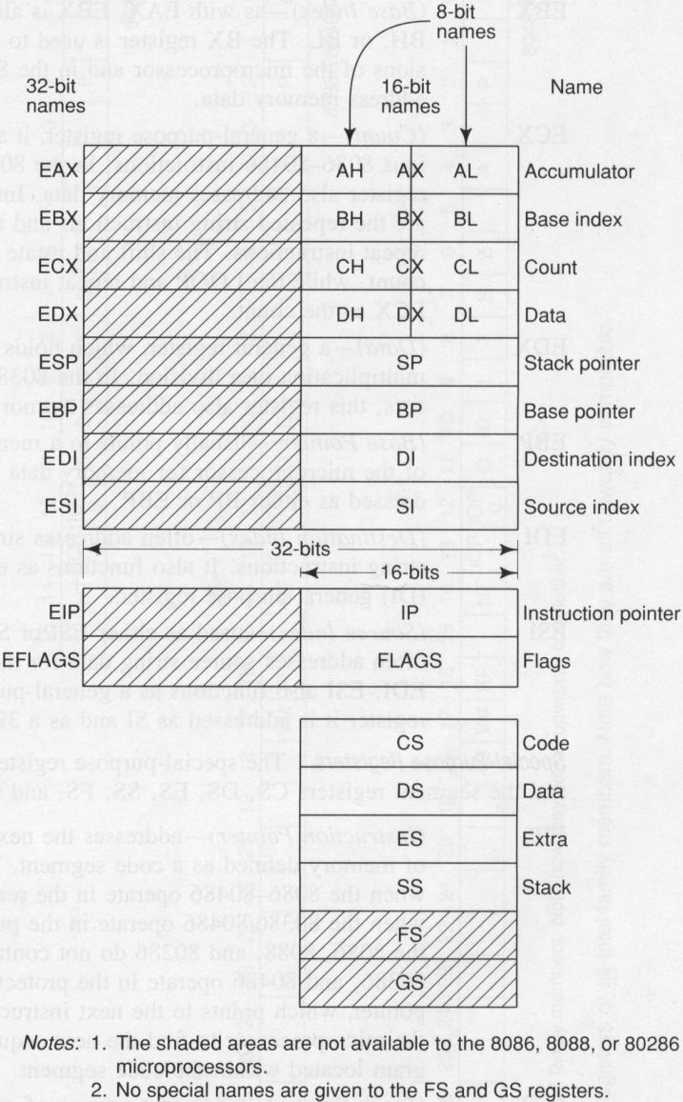

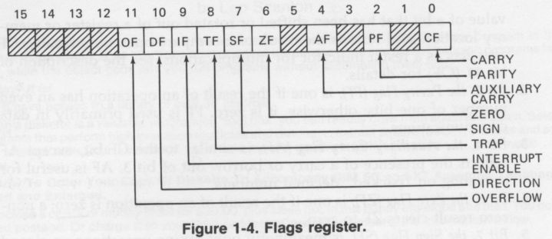

8086 MEMORY MAP
↑ ↑
⏐ 64 K | ROM BIOS | F0000H - FFFFFH
⏐ ↓
384 K ROM | ROM BASIC | Present in older computers
⏐
⏐ | Reserved ROM
⏐
↓ | Video BIOS ROM | C0000H - C7FFFH
↑
⎢ A0000H | Video RAM | A0000H - BFFFFH
⎢
⎢
⎜ | User RAM
640 K RAM
⎜
⎜ | Resident portion of DOS | Varies between 12 K to 40 K
⎜
⎜ | BIOS and DOS data area | 00400H - 005FFH
↓ 1 K | Interrupt Vector Table | 00000H - 003FFH

MEMORY SEGMENTATION

Paragraphs:
The Memory Address Space (MAS) is divided into 65,536 (i.e., 10,000H ) paragraphs.

Each paragraph is 16 (i.e., 10H) consecutive bytes.

Thus each paragraph starts at a physical address whose rightmost hexadecimal digit is zero:

FFFFFH
 |  | 10H bytes Paragraph FFFFH
FFFF0H |  | ↓
FFFEFH
00030H
0002FH
 |  | 10H bytes Paragraph 2H
00020H |  | ↓
0001FH
 |  | 10H bytes Paragraph 1H
00010H |  | ↓
0000FH
 |  | 10H bytes Paragraph 0H
00000H |  | ↓

Physical Memory Segments:
The address bus of the 8086/8088 is 20-bits.

Hence the microprocessor uses 20-bit memory addresses; but its registers are 16 bits.

The concept of memory segmentation is used to solve this problem of using 20-bit addresses in a 16-bit microprocessor.

The 8086/8088 partitions its memory into 65,536 physical memory segments.

A physical memory segment is a block of 2¹⁶ (i.e., 64K or 10,000H) consecutive bytes starting at a paragraph boundary.

The segments overlap but they all begin at different paragraph boundaries.

All segments from the one starting at F0000h to the one starting at FFFF0h wrap around and end at lower memory addresses.

Since each segment starts at a physical address whose leftmost hexadecimal digit is zero, this digit need not be stored, hence a 16-bit segment register can be used to store the remaining four digits of the 20-bit address.

Within a segment, a memory location is specified by giving an offset. This is the number of bytes from the beginning of the segment.

Since a segment is 10,000H bytes, the first byte in a segment has offset 0000h and the last byte has offset FFFFh (Note: Offsets are unsigned numbers).

Thus a memory location may be specified by providing the 16-bit segment base address, and a 16-bit offset, written in the form segment:offset; this is known as a logical address for the memory location.

For example, the logical address A4FB:4872h means offset 4872h within segment A4FBh, that is, the segment starting at physical address A4FB0h. To obtain the corresponding 20-bit physical (i.e., absolute) address, the 8086/8088 microprocessor first shifts the segment base address 4 bits to the left (this is equivalent to multiplying by 10H), and then adds the offset. Thus the physical address for A4FB:4872h is:
A4FB0h
+ 4872h
A9822h (20-bit physical address)
Because segments may overlap, the segment:offset form of an address is not unique for a particular memory location as is the case for the physical address of that memory location. For example consider the following:
Example: For the memory location whose physical address is 1256Ah, give the address in segment:offset form for segments 1256h and 1240h.
Solution: Let X be the offset in segment 1256h and Y the offset in segment 1240h. We have:
- 1256Ah = 12560h + X ⇒ X = 000Ah
hence 1256Ah = 1256:000Ah (1)
- 1256Ah = 12400h + Y ⇒ Y = 016Ah
hence 1256Ah = 1240:016Ah (2)

(1) & (2) ⇒ 1256:000AH = 1240:016AH

 | 000Ah
016Ah | ↓ | ← 1256h
↓ |  | ← 1240h

Example: A memory location has physical address 80FD2h. In what segment does it have offset BFD2h ?
Solution:
physical address = segment * 10h + offset
⇒ segment * 10h = physical address - offset
Hence:
physical address = 80FD2h
- offset = BFD2h
75000h

Thus the segment is 7500h

Program (or Logical) segments
A logical segment is part of a program that is loaded into memory beginning on a paragraph boundary

(thus the base address of a logical segment has a rightmost hexadecimal digit of zero).

A logical segment is contained within a particular physical segment. Since the size of a physical segment is 64K, the maximum size of a logical segment is 64K.

Logical segments may or may not overlap.

There are four types of logical segments: Code segment, Data segment, Extra segment, and Stack segment.

The Code segment contains the instructions of a program. The Data segment provides a read/write memory in which the data of a program can be stored. The Extra segment is usually used for data storage. Some string operations use the Extra segment to handle memory addressing. The Stack segment is used for temporary storage of addresses and data. It is in this segment that the values of the IP register, the Flags register, and other registers are stored whenever an Interrupt or subroutine call occurs.

Every 8086/8088 assembly language program must contain an explicitly defined Code segment. An 8086/8088 assembly language program which generates an executable file with extension .EXE must have an explicitly defined Stack segment. Such a program may or may not contain the Data or the Extra segment. An 8086/8088 assembly language program which generates an executable file with extension .COM has only one explicitly defined segment: the Code segment. The Stack segment for such a program is implicit. Thus the maximum size for an 8086/8088 COM format Assembly language program is 64K.

An EXE format 8086/8088 Assembly language program may contain multiple segments of a certain type; however only four logical segments can be active at a time.

To keep track of the various logical segments, the 8086/8088 uses each of its four segment registers to hold a 16-bit portion (called a segment number) of the 20-bit starting address of a logical segment. The remaining four rightmost bits of the address are implied 0000 because a logical segment starts at a paragraph boundary. The CS, DS, SS, and ES registers contain the code, data, stack, and extra segment numbers, respectively. The segment registers provide the segment base address part of a logical memory address (i.e., segment:offset address):

CS:IP is the segment:offset address of the next instruction to be executed.
DS:offset is the segment:offset address of the byte with the given offset in the data segment.
SS:SP is the segment:offset address of the top of the stack.
SS:BP is the segment:offset address of the byte, in the stack, whose offset is in the BP register.
DS:SI is the segment offset:address of a byte in the data segment at which the source operand of a string instruction starts.
ES:DI is the segment:offset address of a byte in the extra segment at which the destination operand of a string instruction starts.

The segment registers must be loaded with the segment numbers. Just what values are loaded is dependent in part on how the linker and loader have assigned the logical segments to memory locations, and on how the segment registers have been initialized during the loading process. Typically, the CS register will be loaded with the proper code segment number so that, in conjunction with the IP register, the program’s first executable instruction will be referenced. The SS and SP registers will also be properly loaded if the stack segment is explicitly defined in the program. The other segment registers, DS and ES, must be explicitly loaded by the programmer if they are used by the program.

